
Announcement of Nadun Police Station
Regarding the intention not to accept gifts and presents of any kind from performing duties
(No Gift Policy)
------------------------------------
Nadun Police Station is committed to developing transparent operations, adhering to public interest over personal interest, without conflicts of interest, in line with the national reform plan on prevention and suppression of corruption and misconduct (revised version), which aims for agencies to operate transparently and without benefits. All government officials do not accept gifts or presents of any kind in the performance of their duties (No Gift Policy).
Therefore, we hereby announce the intention of the Superintendent of Nadun Police Station and all police officers to not accept gifts or presents of any kind in the performance of their duties (No Gift Policy), jointly create an organizational culture and honest values ​​in performing their duties, do not accept patronage systems, avoid actions that may affect discretion or decision-making in performing duties, leading to discrimination, prevent unfair performance of duties and prevent conflicts of interest, and build public confidence in performing duties with good governance.

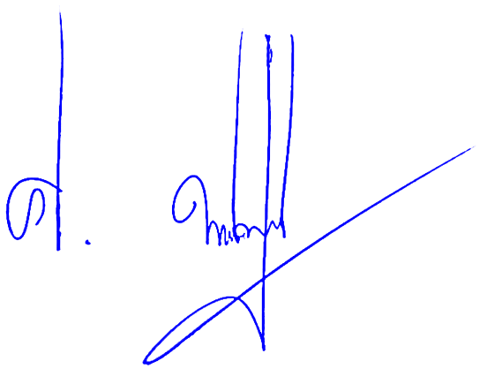
Therefore, we hereby announce for your information and strict compliance.

Announced on January 1, 2026

Pol.Lt.Col.
( Siripong Phahonchaichoopong )
Chief of Inspector of Soem Police Station

